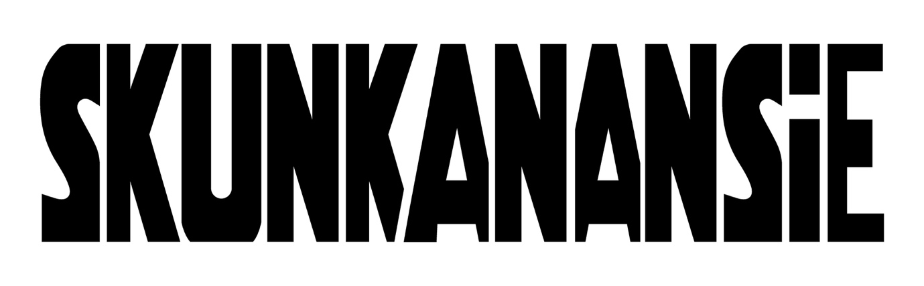

ANNOUNCE UK HEADLINE TOUR
MARCH / APRIL 2025
Photo by India Fleming

FAN PRE-SALE - WEDNESDAY 16TH OCTOBER 2024
SPOTIFY PRE-SALE – THURSDAY 17TH OCTOBER 2024
GENERAL ON SALE – FRIDAY 18TH OCTOBER 2024
TICKETS AVAILABLE AT WWW.SKUNKANANSIE.COM

British rock icons Skunk Anansie roar back into action next year with a huge UK headline tour in Spring 2025. Promising an entirely brand new production, the tour will usher in an exciting new era in the history of this legendary band, with new music also on the horizon.

Formed in London in 1994, Skunk Anansie instantly caught attention with their unique blend of alternative, rock, and punk influences, coupled with a dub sensibility which showcased their multi-cultural background.

Their outspoken lyrics tackling social and political issues, alongside vocalist Skin’s unapologetic queer sexuality and high-fashion aesthetic, meant that they became one of the most talked about and important bands of their generation and quickly led to global success.

With a string of critically acclaimed albums including ‘Paranoid & Sunburnt’, ‘Stoosh’, ‘Post Orgasmic Chill’ and ’25LIVE@25’ and hit singles such as ‘Hedonism (Just Because You Feel Good)’, ‘Selling Jesus’, ‘Twisted (Everyday Hurts)’ and ‘Weak’, Skunk Anansie have sold millions of records around the world and headlined Glastonbury Festival in 1999. After a hiatus in the early 2000s, the band triumphantly reformed in 2009 and have continued to release new music and tour the world ever since.

Skunk Anansie are currently working on new music to follow the band’s acclaimed recent singles ‘Piggy’ and ‘This Means War’. Their return in 2025 will showcase exactly why, over 30 years since their first performances, Skunk Anansie are one of the most powerful and exciting bands on the planet – both as recording artists and live performers.

Regarding the tour, vocalist Skin says, “We are really excited to get getting back on tour, doing what we love the most which is playing live with fire in our belly. This tour will be a completely brand new production and we can’t wait to share it with the UK.”

The 14-date run starts at London’s Roundhouse on March 29th and finishes at Guildford’s G Live on April 16th.

SKUNK ANANSIE – UK TOUR 2025
March 29th London – Roundhouse
March 31st Cardiff – Cardiff University
April 1st Bristol – Bristol Beacon
April 3rd Nottingham – Rock City
April 4th Manchester – O2 Apollo
April 5th Birmingham – O2 Academy Birmingham
April 7th Norwich – The LCR
April 8th Cambridge – Corn Exchange
April 10th Glasgow – O2 Academy Glasgow
April 11th Newcastle – NX Newcastle
April 12th Leeds – O2 Academy Leeds
April 14th Bournemouth - O2 Academy Bournemouth
April 15th Brighton – Brighton Dome
April 16th Guildford – G Live

The fan pre-sale starts on Wednesday 16th October 2024, Spotify pre-sale is available the following day and general on sale commences on Friday 18th October 2024. Tickets will be available via www.skunkanansie.com


Skunk Anansie last month signed with Frontiers Label Group who have formed the new imprint FLG especially for the visionary British rock group. The band will be releasing brand new music in 2025, with further announcements to come in due course.

About the signing the band commented, “Skunk Anansie are delighted to sign with FLG. For us, this is also the beginning of a new phase of our career and we are deeply excited to be working with them. We are thankful that FLG has decided to join us in creating a fresh vision and new musical direction as well as celebrating our many musical achievements. We look forward to a bright future and some most exciting music”.



PRAISE FOR SKUNK ANANSIE LIVE

“Skunk Anansie are as sharp-edged and occasionally confrontational as ever they were”
Kerrang! KKKK

“A ribcage-rattling homecoming for this glorious powerhouse of rock”
Daily Telegraph 5*

“Skin’s megawatt presence as a queer, black rock frontwoman has never seemed more vital… en route to this ferocious climax there were molten riffs and soaring vocals to spare”
The I Newspaper

“Visually and musically, they appeared as fresh and unique as they have ever been… judging from this performance there is still much more to come from Skunk Anansie.”
Louder Than War

FURTHER INFORMATION ON SKUNK ANANSIE
Skunk Anansie, formed in 1994 in London, are a seminal band; one of the first multi-racial British rock bands, who are known for their powerful sound and thought-provoking lyrics. Fronted by the charismatic and dynamic vocalist Skin, the band blends alternative rock with elements of punk and metal. They remain one of the most important and influential bands of their era.

Their debut album Paranoid & Sunburnt (1995) and its follow up Stoosh (1996) both hit the Top 10 album chart in the UK, and with hits like ‘Weak’ and ‘Hedonism’, they established themselves on the international stage, helped by their stunning live performances. In 1999, Skunk Anansie closed the decade off in style by releasing their third studio album, Post Orgasmic Chill and headlining Glastonbury Festival, before surprisingly going on a lengthy hiatus in 2001.

The band reconvened in 2008 to embark on the second chapter of their career, releasing three acclaimed albums - 2010’s Wonderlustre, 2012’s Black Traffic and 2015’s Anarchytecture. In 2019, the band marked their 25th anniversary with 25LIVE@25, a live album that brings together the greatest songs from their six studio albums.

Throughout their career, Skunk Anansie have sold over five million records around the world. The band’s international prominence continues to thrive today, selling out live arenas and headlining festivals across the continent.

Skunk Anansie are celebrated for addressing political and social issues through their music, breaking racial and gender barriers in rock. Their influence extends beyond music, contributing to discussions on identity, equality, and activism.

For more information contact Wilful Publicity
william.luff@wilfulpublicity.co.uk / david.sullivan@wilfulpublicity.co.uk

